VPN Sneak

1st Chirag Sanjay Ferwani   
*dept. of Information Technology*  
*Pimpri Chinchwad Polytechnic*Pune, Maharashtra  
chiragferwani@gmail.com

4th Atharva Abhay Kakade  
*dept. of Information Technology*  
*Pimpri Chnichwad Polytechnic*Pune, Maharashtra  
k.atharva1903@gmail.com2nd Nitanshu Shridhar Bhor  
*dept. of Information Technology*  
*Pimpri Chinchwad Polytechnic*Pune, Maharashtra  
nitanshu.bhor20@gmail.com

5th Sonali. L. Mortale  
*dept. of Information Technology*  
*Pimpri Chinchwad Polytechnic*Pune, Maharashtra  
sonali.mortale@gmail.com3rd Yash Kiran Chavan  
*dept. of Information Technology*  
 *Pimpri Chinchwad Polytechnic*Pune, Maharashtra  
yashkiranchavan05@gmail.com

*Abstract*— This research paper conducts a thorough investigation into VPN technologies, spanning from mobile applications to solutions based on Raspberry Pi. It evaluates the user-friendliness and security features of mobile VPN apps, concurrently exploring the versatility of VPN servers constructed on Raspberry Pi. This comparative analysis provides valuable insights for individuals and organizations seeking reliable VPN options within the framework of a privacy-centric digital landscape.

Keywords— VPN technologies, Mobile VPN applications, Raspberry Pi-based VPN solutions, User-friendliness, Security aspects, Comparative analysis, VPN server adaptability and availability, Privacy-focused environment, Digital privacy, Online security, VPN choices, Privacy-enhancing technologies, Network security, VPN server deployment, Privacy considerations.

# Introduction

In the age defined by unparalleled digitization and the pervasive interconnectivity facilitated by the internet, the preservation of data privacy and security stands as an imperative priority. Virtual Private Networks (VPNs) have emerged as indispensable tools, fortifying online communications and shielding sensitive information. This research paper embarks on an extensive examination of VPN technologies, encompassing a wide spectrum of solutions ranging from mobile applications to innovative implementations utilizing Raspberry Pi. By scrutinizing the nuances of these varied VPN approaches, this study endeavors to provide invaluable insights to both individual users and organizations confronting the challenge of establishing secure and anonymous digital connections. As our globally linked landscape continues to evolve, the demand for resilient VPN solutions has reached unparalleled levels. This exploration aims to illuminate the array of available options, facilitating informed decisions regarding VPN adoption in an era where safeguarding online privacy reigns supreme.

# CORE OF VPN FUNDAMENTALS

## Exploring Virtual Private Networks

In the realm of cybersecurity and data privacy, Virtual Private Networks (VPNs) have emerged as indispensable and adaptable technologies. In an era where online communication and data exchange are omnipresent, the imperative for secure and private connections has reached new heights. Fundamentally, a VPN functions as a network technology that establishes encrypted and secure connections across public networks, often the internet. This innovation empowers individuals, businesses, and organizations to shield their online activities and sensitive data from potential threats, constructing a protected pathway through the inherently vulnerable cyber landscape. Beyond fortifying against cyber threats, VPNs serve to circumvent geo-restrictions, amplifying users' online freedom and accessibility to content and services transcending geographical barriers.

As our digital footprint expands and cybersecurity risks evolve, unraveling the operational intricacies of VPNs becomes imperative. This research paper delves deeply into the intricate mechanisms and functionalities of VPNs, exploring their prowess in forging secure connections, encrypting data, and ensuring user anonymity. Additionally, it investigates the multifaceted applications of VPN technology, spanning from enabling remote work and ensuring secure corporate communications to preserving individual privacy in an era shadowed by widespread surveillance. Moreover, this paper will scrutinize the security implications linked to VPN usage, addressing potential vulnerabilities, advocating for best practices in selection and configuration, and underscoring the pivotal role of VPNs in upholding online privacy and safeguarding sensitive information. Ultimately, this research strives to offer a comprehensive comprehension of VPNs and their pivotal role in bolstering cybersecurity, preserving data privacy, and fostering a secure and open digital landscape within our increasingly interconnected digital sphere..

## Significance of VPNs in Safeguarding Online Privacy

In the contemporary landscape marked by extensive digital surveillance and widespread data collection, Virtual Private Networks (VPNs) assume a pivotal role in upholding online privacy. At its essence, a VPN functions as a protective barrier, establishing a secure and encrypted passage between a user's device and the internet. This mechanism conceals their IP address and online activities, safeguarding sensitive data—personal information, financial transactions, and browsing history—from potential threats like hackers, ISPs, and governmental entities. Through this encryption, VPNs ensure the confidentiality of information, preserving it from prying eyes.

By directing internet traffic through servers situated in diverse geographical locations, VPNs facilitate anonymity and enable users to surpass geo-restrictions, fostering a global internet experience while preserving their identity. Essentially, VPNs furnish individuals, businesses, and organizations with the tools to assert control over their online presence and reclaim their entitlement to digital privacy amidst the escalating trends of digital surveillance and commercialization of data.

## Insights for Users and Entities

Derived from the rigorous comparative analysis presented in this research, conclusive insights emerge to guide individuals and entities in their pursuit of dependable VPN solutions. The examination of mobile VPN applications and Raspberry Pi-based solutions offers valuable perspectives on their respective strengths and weaknesses. For individuals seeking user-friendly experiences. The research provides nuanced recommendations based on ease of use in mobile applications and the adaptability of Raspberry Pi-based VPN servers. Additionally, entities concerned with robust security measures will find tailored recommendations addressing encryption protocols, authentication mechanisms, and overall security features.

These insights serve as a compass, empowering users and entities to make informed decisions tailored to their specific needs and preferences in the dynamic landscape of VPN solutions.

## Privacy-Focused Digital Environment

In the rapidly evolving digital landscape, the discourse surrounding online privacy has become pivotal, especially within the framework of a privacy-focused digital environment. This section delves into the broader context, shedding light on the heightened awareness and emphasis on individual and organizational privacy in today's interconnected world. As users navigate the complexities of the digital realm, the choices they make regarding Virtual Private Networks (VPNs) carry profound implications. The research explores how VPN choices play a crucial role in safeguarding sensitive data, mitigating risks associated with online activities, and fortifying the privacy rights of both individuals and organizations. By understanding the dynamic interplay between VPN solutions and the prevailing privacy-focused ethos and privacy considerations.

## User Friendly VPNs

Within the realm of VPN adoption, the evaluation of user-friendliness emerges as a critical determinant. This research scrutinizes the user experience, comparing the ease of use between mobile VPN applications and Raspberry Pi-based solutions. An in-depth analysis is conducted to assess the intuitive interfaces, setup processes, and overall accessibility of both types of VPNs. By juxtaposing the user-friendliness of mobile applications and the adaptability of Raspberry Pi-based servers, this study provides valuable insights into the factors influencing user adoption and satisfaction. As user-friendliness plays a pivotal role in the widespread acceptance of VPN solutions, the comparative examination serves to elucidate the strengths and considerations associated with each approach, guiding users towards solutions aligned with their preferences and technological proficiency.

# Raspberry Pi: A CUSTOM VPN Solution

The versatile single-board computer, Raspberry Pi, introduces an innovative and cost-efficient approach to establishing a personal Virtual Private Network (VPN). Leveraging the capabilities of Raspberry Pi alongside open-source VPN software such as OpenVPN or WireGuard empowers tech enthusiasts and privacy-conscious users to forge a secure and secluded network connection within their own spaces. This DIY VPN solution not only ensures robust defense against cyber threats but also grants complete customization and governance over the network's security parameters. With its compact size and energy efficiency, Raspberry Pi emerges as an optimal choice for constructing a personalized VPN, presenting a budget-friendly and empowering avenue to fortify online privacy and security.

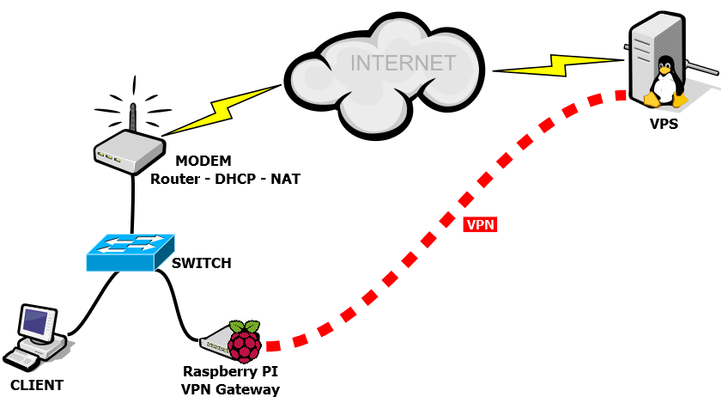

Figure 1: An example of Raspberry Pi can serve as a personal VPN Server

## Utilizing Raspberry Pi for Deploying Personal VPNs

* Raspberry Pi's Role in Online Security: Raspberry Pi, an economical single-board computer, revolutionizes individual online security.
* Adaptable VPN Solutions: It presents an easily tailored solution for crafting individual VPNs.
* Integration with Open-Source VPNs: Raspberry Pi seamlessly integrates with open-source VPN software like OpenVPN or Wire Guard.
* Establishing Private Internet Passages: Users can create private internet tunnels ensuring robust data encryption.
* Heightened Privacy Assurance: This shields data from potential threats and intrusive surveillance efforts.
* IP Address Concealment: Raspberry Pi-powered VPNs enable users to mask their IP addresses effectively.
* Surpassing Geographical Restrictions: They allow effortless bypassing of content restrictions based on location, granting enhanced online liberty.
* Customization Potential: Raspberry Pi's adaptability empowers users to customize VPNs for specific purposes.
* Secured Remote Connectivity: It offers a secure avenue for remote connections.
* Privacy in Browsing: Ideal for maintaining anonymity during internet browsing sessions.
* Accessing Restricted Content: Users effortlessly access region-locked content.
* User-Friendly Interface: Raspberry Pi boasts a user-friendly interface for enhanced usability.
* Energy Efficiency: With minimal energy consumption, it proves cost-effective in the long run.
* Uplifting Online Privacy: Raspberry Pi emerges as a budget-friendly means to fortify online privacy and security.

## Securing Your Raspberry Pi VPN Setup

Establishing a Raspberry Pi-based VPN marks only the initial step; ensuring its security remains equally paramount. Post VPN software deployment on Raspberry Pi, prioritizing top-tier security becomes imperative. This entails configuring robust encryption protocols, regularly updating the VPN software to address vulnerabilities, and implementing stringent authentication methods. Furthermore, fortifying the Raspberry Pi itself holds significance—altering default credentials, activating a firewall, and restricting external access. Adhering to these best practices and maintaining a vigilant stance toward security measures assures the advantages of a self-hosted VPN, safeguarding both your data and network integrity. Bear in mind, a well-secured and meticulously configured Raspberry Pi VPN stands as a potent asset in your pursuit of online privacy and security within the realm of VPN technologies.

## Comparison with Traditional VPN Solutions

In conducting a comparative analysis between Raspberry Pi-based custom VPN solutions and traditional VPN services, it becomes evident that each approach bears distinct strengths and weaknesses, catering to diverse user needs and preferences. Traditional VPN services, often hosted by third-party providers, excel in providing hassle-free, ready-to-use solutions. They typically boast extensive server networks across the globe, ensuring reliable and high-performance connections. While offering user-friendly interfaces, traditional VPNs may, however, raise concerns about user data privacy, as reliance on external servers involves trusting third-party entities with sensitive information.

On the other hand, Raspberry Pi-based custom solutions empower users with a heightened level of control and customization. Users can tailor security settings, encryption protocols, and server configurations based on their specific requirements. This approach grants greater transparency and allows users to ensure that their privacy is maintained within their self-hosted environment. However, the custom solution may pose challenges in terms of scalability, as it may require more active involvement in setup and maintenance. As such, the choice between traditional VPN services and Raspberry Pi-based custom solutions depends on individual priorities, with traditional VPNs offering convenience, and Raspberry Pi-based solutions providing a more hands-on and privacy-centric approach.

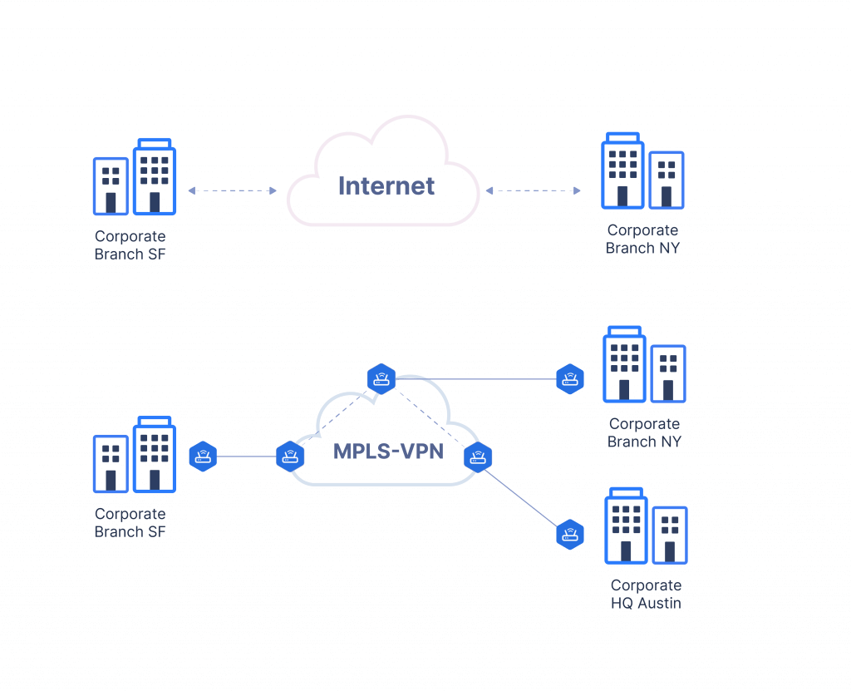

Figure 2: An example of corporate VPN solution

## Easy Setup and Maintenance

The ease of setup and maintenance is a pivotal factor influencing the adoption of Raspberry Pi-based custom VPN solutions. Analyzing the process reveals that users benefit from a user-friendly interface and step-by-step procedures, making the deployment of a custom VPN server accessible to a broad audience. Raspberry Pi's intuitive design facilitates a streamlined setup, where users are guided through the necessary configurations without requiring extensive technical expertise. This simplicity enhances the appeal of Raspberry Pi as a platform for those seeking a hands-on approach to VPN deployment.

Moreover, the maintenance aspect is marked by the straightforward management of Raspberry Pi-based VPN servers. Routine tasks such as software updates, security patches, and system tweaks are typically managed through simplified processes. Users can engage in efficient troubleshooting and regular upkeep without grappling with intricate complexities. This user-friendly ecosystem ensures that individuals, even with limited technical proficiency, can establish and maintain a custom VPN server on Raspberry Pi with confidence. In essence, the emphasis on ease of setup and maintenance positions Raspberry Pi as an accessible and empowering platform for those venturing into the realm of self-hosted VPN solutions.

# Ensuring Data Protection Using VPN

Security and encryption serve as the cornerstone of Virtual Private Networks (VPNs), forming an impenetrable shield for internet traffic. These technologies establish a secure pathway, rendering online activities impervious to potential threats and prying eyes. Cutting-edge encryption protocols, notably AES-256-bit, ensure data confidentiality, even in untrusted network environments. Moreover, VPNs employ authentication methods to authenticate both user and server identities, fortifying security measures. Amidst escalating cyber threats and data privacy concerns, VPNs emerge as a robust defense, granting users the confidence to navigate, communicate, and engage in online tasks, assured that their information remains safeguarded from cyber threats and surveillance.

## Encryption Standards in VPNs

Encryption protocols serve as the bedrock of Virtual Private Networks (VPNs), safeguarding the privacy and integrity of data transmitted across the internet. These protocols dictate the process of encoding data before transmission and subsequently decrypting it upon arrival at its destination. Among the array of encryption standards, AES (Advanced Encryption Standard) stands out as widely adopted and trusted for its robust symmetric encryption, presenting formidable barriers against unauthorized access. Additionally, protocols like OpenVPN, L2TP/IPsec, and IKEv2/IPsec each offer distinct strengths and applications. Grasping the subtleties of these encryption protocols proves pivotal when choosing a VPN service, directly influencing the level of security and operational efficiency. Selecting the optimal protocol hinges upon specific needs—be it stringent security measures, speed optimization, or device compatibility. Ultimately, encryption protocols form the foundation of VPNs, furnishing the confidence of privacy and security within an ever-evolving digital landscape.

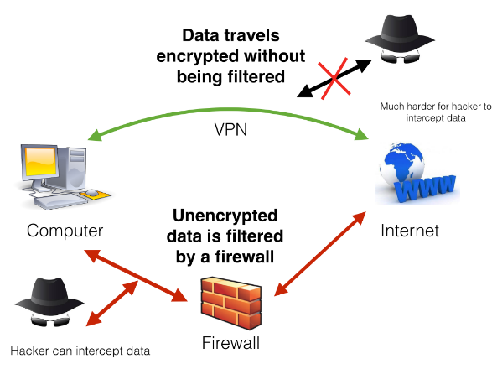

Figure 3: A sample image of how Encrypted VPN works

## Securing Data Integrity in Virtual Private Networks

Within the realm of Virtual Private Networks (VPNs), upholding data integrity emerges as a pivotal concern. Securing data during transmission isn't sufficient; it must arrive at its destination untainted and unaltered. To ensure this, VPNs employ cryptographic hashing functions. These functions generate distinct hash values for data packets, sent alongside the packets themselves. Upon receipt, recalculating the hash values permits verification—if they align with the transmitted values, it confirms the data's integrity and unchanged state during transit. Detection of any tampering prompts the rejection of unreliable data. By guaranteeing data integrity, VPNs not only thwart eavesdropping but also affirm that received information mirrors the sent data, preserving the reliability and credibility of data exchanges. This holds particular significance for businesses, remote workers, and individuals transmitting sensitive data over the internet—assuring them that their data remains unaltered and secure, instilling confidence in the exchange process.

## Firewall Configurations

The evaluation of firewall configurations within VPN setups constitutes a crucial aspect of network security, warranting an in-depth examination of how firewalls contribute to safeguarding data and fortifying against unauthorized access. This research scrutinizes the specific configurations employed in VPN environments, analyzing the role of firewalls in controlling incoming and outgoing traffic. The assessment encompasses aspects such as packet filtering, stateful inspection, and proxy services to understand how these configurations collectively establish a robust defense against potential threats. By scrutinizing the intricacies of firewall settings, the research aims to elucidate the impact on network security and how these configurations align with the overarching goals of VPN protection.

Firewalls play a pivotal role in orchestrating the security posture of VPN setups, and their configurations are pivotal in determining the efficacy of network defenses. This discussion dives into the nuances of firewall configurations, exploring how they act as a barrier against unauthorized access and potential cyber threats. The research considers the dynamic nature of VPN traffic, evaluating how firewalls adapt to changing patterns while maintaining a secure perimeter. The assessment encompasses the utilization of firewalls for intrusion prevention, detection of malicious activities, and the enforcement of security policies. By shedding light on the intricacies of firewall configurations, the research contributes valuable insights into their role as a fundamental component in ensuring the security and integrity of VPN connections.

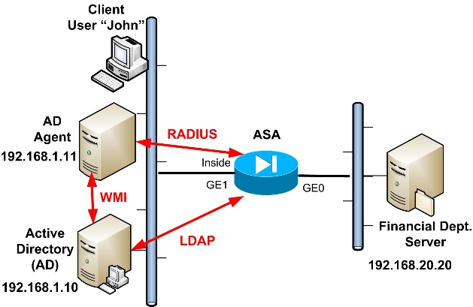

Figure 4: A sample image of Firewall usage in VPN

## Authentication Mechanism

Within the realm of VPNs, the efficacy of authentication mechanisms plays a pivotal role in fortifying the security posture of these network connections. This research scrutinizes the diverse authentication methods employed in VPN setups, ranging from traditional username-password combinations to more advanced multifactor authentication (MFA) protocols. The examination delves into the intricacies of each method, assessing their effectiveness in safeguarding user credentials and preventing unauthorized access. By investigating the robustness of authentication mechanisms, the research aims to offer insights into the reliability of these security measures, shedding light on their resilience to common threats such as brute-force attacks and credential theft.

The effectiveness and reliability of various authentication mechanisms are critical considerations in ensuring the integrity of VPN connections. This discussion delves into the nuances of each authentication approach, weighing factors such as ease of implementation, user experience, and resistance to cyber threats. Traditional methods, such as password-based authentication, are evaluated alongside more advanced techniques like biometric authentication and token-based systems. The research assesses the trade-offs between security and convenience, recognizing that the most effective authentication mechanism is one that not only thwarts malicious actors but also aligns with user expectations for a seamless and user-friendly experience. Through this exploration, the research contributes valuable insights into selecting and implementing authentication methods that strike the right balance between security and usability within the context of VPNs.

## Emerging Trends in VPN Security

The exploration of emerging trends in VPN security stands as a pivotal aspect of this research, providing an overview of the dynamic landscape where new technologies and approaches continuously shape the security paradigm of VPNs. This analysis encompasses a thorough examination of recent advancements, including but not limited to zero-trust architectures, post-quantum cryptography, and decentralized VPN solutions. By offering an overview of these trends, the research aims to shed light on how they contribute to enhancing the overall security posture of VPNs and addressing contemporary challenges.

The ever-evolving nature of cyber threats prompts a constant evolution in VPN security strategies. This research delves into the forefront of emerging trends, considering how new technologies and approaches are reshaping the security landscape of VPNs. It explores the rising prominence of zero-trust architectures, which challenge traditional notions of perimeter security, and the adoption of post-quantum cryptography to fortify VPNs against potential quantum threats. Additionally, the research considers decentralized VPN solutions that leverage blockchain or distributed technologies to enhance user privacy. By providing an overview of these cutting-edge trends, the research offers valuable insights into the future of VPN security, empowering users and entities to stay abreast of innovations that can bolster the resilience of their VPN deployments.

## VPN Tunneling Protocols

The discussion on VPN tunneling protocols constitutes a pivotal exploration within the realm of VPN technology. This research delves into the diversity of tunneling protocols employed by VPNs, assessing their respective impacts on data security, privacy, and overall VPN performance. The analysis includes an in-depth examination of prominent protocols such as OpenVPN, IPSec, L2TP, and PPTP, unveiling their strengths, weaknesses, and suitability for different use cases. By scrutinizing these protocols, the research aims to elucidate their role in establishing secure communication channels, ensuring data privacy during transit, and influencing the overall efficiency of VPN connections.

The landscape of VPN tunneling protocols is multifaceted, with each protocol contributing distinct attributes to the security and performance of VPN connections. This research engages in a comprehensive assessment of these protocols, considering factors such as encryption methods, authentication processes, and the adaptability to diverse network environments. The impact on data security and privacy is meticulously analyzed, weighing the trade-offs between security measures and the potential impact on overall VPN performance. By offering insights into the nuanced differences among tunneling protocols, the research aims to guide users and entities in selecting the most suitable protocol tailored to their specific security and performance requirements within the context of VPN deployments.

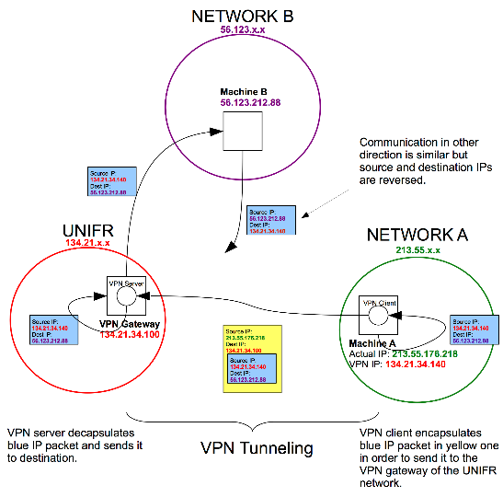

Figure 5: Tunneling technologies used by VPN services

# Overcoming Geographic Limits With VPNs

Geo-restrictions, often enforced by content providers or governments, restrict access to specific online content based on geographic location. Virtual Private Networks (VPNs) emerge as a potent solution to overcome these limitations. By directing internet traffic through servers situated in diverse regions or countries, VPNs effectively conceal the user's actual location and allocate a new IP address. This enables users to unlock region-locked content, stream services, or access websites that may otherwise be unavailable in their vicinity. Whether it involves exploring streaming platforms, news sites, or online services, VPNs empower users to navigate the global internet without being hindered by the constraints imposed by geo-restrictions.

## VPN Solutions: Bypassing Geo-Blocked Content

In an increasingly interconnected digital landscape, the internet serves as a vast reservoir of information, entertainment, and services. However, content providers and governments implement geo-blocking, restricting access to specific online content based on geographical locations. This limitation proves vexing for users aspiring to access region-specific websites, streaming services, or digital resources. Enter Virtual Private Networks (VPNs). Offering an ingenious solution, VPNs redirect internet traffic through servers situated in various regions or countries, effectively concealing the user's genuine location and assigning a new IP address. As a result, users transcend geo-blocking, obtaining desired access to streaming services, websites, or online gaming platforms. Beyond privacy and security, VPNs empower users to explore the global internet unimpeded by geographic barriers, enabling a seamless online experience.



Figure 6: Geographic distribution of vantage points for popular VPN services

## Circumventing Censorship

Circumventing censorship stands as a crucial aspect of VPNs' societal impact, particularly in regions where access to information is restricted. VPN Sneak, among other VPNs, plays a pivotal role in empowering users to navigate around censorship barriers imposed by governments or other entities. By encrypting internet traffic and rerouting it through servers located in different regions, VPNs create a virtual tunnel that shields users' online activities from potential surveillance. This not only preserves users' privacy but also enables them to access websites, content, and communication platforms that may be blocked or restricted in their geographic location. The ability to circumvent censorship through VPNs represents a digital lifeline for individuals seeking to exercise their freedom of expression and access unrestricted information in environments where such freedoms are curtailed.

While the capability of VPNs to circumvent censorship is a powerful tool for promoting online freedom, it also raises legal and ethical considerations. Governments and content providers may view VPN usage as a challenge to their authority or business models, leading to potential conflicts. The research delves into these complexities, examining the delicate balance between users' rights to access information freely and the regulatory measures implemented to maintain control over internet content. By exploring both the empowering potential and the challenges associated with VPNs in circumventing censorship, the research contributes to a nuanced understanding of the broader implications for digital freedom and information access.

## Legal and Ethical Considerations

Legal and ethical considerations form a critical backdrop in the deployment and use of VPNs, including VPN Sneak. As VPNs provide users with the ability to bypass geo-restrictions, circumvent censorship, and safeguard their online privacy, navigating the legal landscape becomes paramount. The research dives into the intricate web of laws and ethical frameworks that govern VPN usage, addressing the delicate balance between users' rights and the regulatory measures imposed by governments and content providers.

The legal considerations surrounding VPNs vary globally, with some countries embracing these tools as essential for privacy protection, while others may impose restrictions or outright bans. The research explores jurisdictional differences, shedding light on how VPNs navigate diverse legal landscapes. It examines cases where VPN usage might conflict with regional regulations, potentially raising questions about the legality of circumventing geo-restrictions or accessing censored content.

Ethical considerations are equally crucial, as VPNs play a dual role in preserving individual freedoms and potentially challenging established content distribution models. The research delves into the ethical implications of VPN usage, considering the responsibilities of VPN providers to ensure their services are not misused for malicious activities. By scrutinizing the legal and ethical dimensions, the research aims to foster a comprehensive understanding of the broader implications of VPNs, informing users, policymakers, and VPN providers about the delicate balance between privacy, freedom, and adherence to legal and ethical norms.

## Proxy Servers Versus VPNs: A Comparison

When circumventing geographical restrictions, both proxy servers and Virtual Private Networks (VPNs) play distinct roles, offering varying levels of efficacy and security. Proxy servers serve as intermediaries between users and websites, concealing user IP addresses but often lacking encryption and security measures. While aiding access to geo-restricted content, they might not be optimal for prioritizing privacy and security.

Conversely, VPNs not only alter user IP addresses but also encrypt internet traffic, ensuring heightened security and anonymity. Typically, VPNs prove more proficient at bypassing geo-blocks, presenting a comprehensive solution inclusive of privacy and security measures. Ultimately, the decision between a proxy server and a VPN hinges on individual requirements, with VPNs emerging as the preferred choice for those seeking both content accessibility and robust online security within the realm of VPN Technologies.

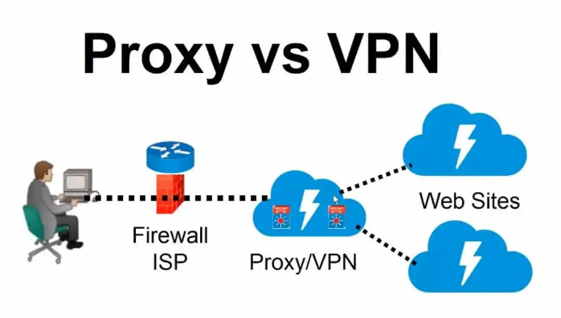

Figure 7: A sample graph on the user count of proxy servers with respect to virtual private networks

# Evaluating VPN Speed and Performance

Evaluating the performance and speed of a VPN proves pivotal in gauging its efficacy within a Virtual Private Network infrastructure. These assessments measure the VPN's efficiency in encrypting and transmitting data while upholding swift connection speeds. Vital performance metrics encompass latency, upload and download speeds, and server response times.

## Assessing VPN Performance: Methods and Metrics

The assessment of VPN performance involves a comprehensive approach encompassing diverse methodologies and critical metrics. Crucial considerations involve connection speed, latency, and server load. Speed assessments, focusing on upload and download speeds, offer insights into the VPN's impact on internet connectivity.

Reduced latency signifies a more agile VPN, particularly essential for time-sensitive applications such as video conferencing or online gaming. The server load, indicative of the users on a VPN server, directly influences performance, potentially leading to slower speeds and diminished reliability when servers are overloaded.

Moreover, evaluating the encryption overhead of a VPN holds significance; robust encryption may marginally affect data transfer speed while significantly enhancing security. Employing these methodologies and metrics empowers users to make informed decisions when selecting a VPN service that aligns with their performance and security prerequisites within the domain of VPN Technologies.

1. Metrics for VPN Performance Evaluation

|  |  |  |
| --- | --- | --- |
| SrNo | Metric | Description |
|  | Bandwidth | Measures the maximum data transfer rate of a network. |
|  | CPU Utilization | Measures the percentage of CPU resources used by the VPN. |
|  | Protocol Overhead | Measures the additional data used by the VPN protocol for encapsulation and encryption. |
|  | Connection Establishment Time | Measures the time taken to establish a VPN connection. |
|  | Reliability | Measures the consistency and dependability of the VPN service. |
|  | Security | Evaluates the effectiveness of encryption and authentication protocols used in the VPN. |
|  | Scalability | Measures the ability of the VPN to handle increased users or network load. |
|  | VPN Tunnel Stability | Measures the consistency and stability of the VPN tunnel over time. |
|  | User Experience | Subjective evaluation considering ease of use, accessibility, and overall satisfaction of VPN users. |

## Assessing VPNs' Impact on Internet Speed

Analyzing how VPNs affect internet speed provides crucial insights into their operational efficiency. Rigorous testing commonly demonstrates a decrease in connection speed owing to encryption and routing processes involved in VPN usage. Variations in download/upload speeds stem from diverse VPN services, server locations, and employed protocols. Notably, well-optimized VPNs often exhibit reduced latency. It becomes pivotal to weigh the compromise between heightened security and potential speed declines during VPN performance assessments. Additionally, variables like server locations, server loads, and network congestion significantly influence outcomes. A meticulous examination of these findings enables users to judiciously select VPN configurations that strike a balance between privacy and performance, tailored to their specific requirements within the realm of VPN Technologies.

## Real-world Scenarios

In the realm of VPN performance assessment, real-world scenarios serve as a litmus test for evaluating the practical efficacy of VPN Sneak. This facet of the research focuses on examining how VPN Sneak performs in authentic usage situations, including activities like streaming, online gaming, and file transfers. The research paper aims to provide a holistic understanding of the user experience by investigating how VPN Sneak navigates the intricacies of these everyday internet activities.

Streaming is a prevalent online behavior, and VPN Sneak's capability to ensure smooth streaming experiences is explored in the research. The analysis delves into how VPN Sneak handles content delivery, mitigates buffering, and maintains video quality during streaming sessions. Similarly, the research scrutinizes VPN Sneak's impact on online gaming, evaluating factors such as latency, connection stability, and overall gaming performance. Additionally, file transfers, a common task for users, are examined to understand how VPN Sneak facilitates secure and efficient data transmission.

By scrutinizing VPN Sneak's performance in these real-world scenarios, the research paper provides practical insights for users seeking a VPN service that aligns with their specific needs and internet usage patterns. The findings contribute to a nuanced understanding of VPN Sneak's capabilities, guiding users in making informed decisions based on how the VPN performs in scenarios integral to their daily online activities.

## Server Load and Latency

Server load and latency are pivotal metrics in evaluating the overall performance and responsiveness of VPNs, and these aspects are crucial in the context of VPN Sneak. Server load refers to the volume of user requests and activities on a specific VPN server at any given time. High server loads can lead to latency, causing delays in data transmission between the user's device and the VPN server. In the research paper, an in-depth examination of server load and latency provides insights into how VPN Sneak optimizes server distribution and load balancing strategies to maintain an efficient and responsive network. By strategically distributing user requests across multiple servers, VPN Sneak aims to minimize server load, consequently reducing latency and enhancing the overall user experience.

The impact of server load and latency extends beyond individual user experiences; it also influences the scalability and reliability of VPN Sneak's infrastructure. The research delves into how VPN Sneak addresses these challenges, exploring load balancing mechanisms and server optimization strategies. Understanding how VPN Sneak manages server load and latency is crucial for users seeking a VPN service that not only prioritizes privacy but also delivers consistent and high-performance connectivity. By dissecting these technical intricacies, the research paper contributes to a comprehensive understanding of how VPN Sneak navigates server-related challenges to offer users a seamless and responsive VPN experience.

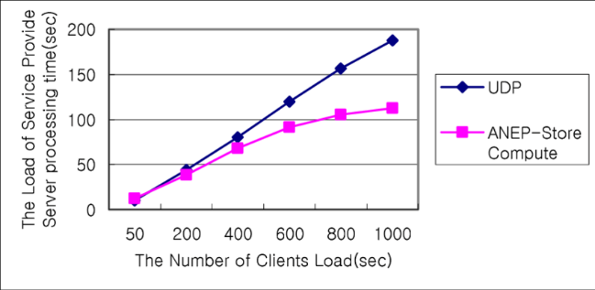

Figure 8: A sample graph based on service provide server load

# Ethical and Legal Implications on VPN Usage

The utilization of Virtual Private Networks (VPNs) necessitates awareness of legal and ethical considerations. Despite offering heightened online privacy and security, VPN usage must align with legal frameworks and ethical standards. Regulations in certain regions may govern VPN usage, and circumventing geo-restrictions might violate content provider agreements. Furthermore, ethical dilemmas can arise if VPNs are employed for unlawful activities such as hacking or piracy. Responsible and lawful VPN usage demands compliance with local regulations and a commitment to ethical online behavior. This ensures that the advantages of augmented privacy and security are enjoyed within the confines of lawful and societal parameters within the realm of VPN Technologies.

## Legal Aspects in VPN Usage

The legal framework surrounding VPN utilization encompasses privacy, jurisdiction, and regulation, forming a complex landscape. Despite their intended role in preserving online privacy, VPNs often encounter scrutiny due to potential misuse. Variations in privacy laws across countries significantly impact the legality and adherence of VPN services. Jurisdiction assumes significance as VPN providers operate within the legal frameworks of their respective countries, influencing data retention and disclosure policies. Additionally, understanding the regulatory environment is crucial, as certain nations impose restrictions or monitoring on VPN usage, citing reasons such as national security concerns. Navigating these legal complexities necessitates a nuanced comprehension of both local and international laws, ensuring that VPN use remains within legal bounds and upholds individual and societal privacy rights within the domain of VPN Technologies.

## Global Jurisdictional Variances

Global jurisdictional variances play a pivotal role in shaping the legal framework within which VPN services operate. The research explores the diverse regulatory landscapes governing VPN usage across different countries, recognizing the substantial differences in laws and policies. Countries have distinct approaches to online privacy, data protection, and telecommunications regulations, creating a complex tapestry of legal considerations for VPN services like VPN Sneak. Understanding these variations is crucial to comprehend how VPN Sneak aligns with the legal requirements of the regions it serves. By navigating the intricacies of global jurisdictional variances, VPN Sneak aims to establish a service that not only prioritizes user privacy but also operates in compliance with the diverse legal standards worldwide.

In addressing global jurisdictional variances, VPN Sneak employs a meticulous approach to legal compliance. The research delves into VPN Sneak's strategies for adapting its services to meet the legal requirements of specific jurisdictions while ensuring a consistent and reliable user experience. This involves continuous monitoring of legal developments, robust legal counsel, and agile policy adjustments. VPN Sneak's commitment to adhering to global jurisdictional standards underscores its dedication to providing a trustworthy and legally compliant VPN service that users can confidently utilize across various regions, respecting the unique legal contexts of each jurisdiction.

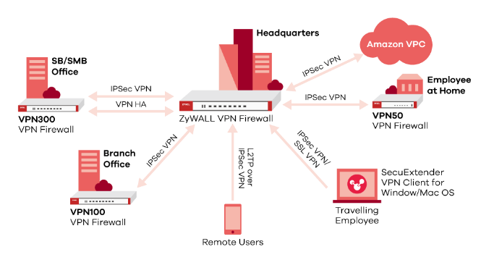

Figure 9: A sample image of Global companies using VPN

## Government Surveillance and Data Retention

Government surveillance and data retention policies constitute a critical aspect of the legal and ethical landscape surrounding VPN services like VPN Sneak. The research delves into the multifaceted dimensions of government surveillance practices and data retention regulations that impact VPN users globally. Governments may implement surveillance mechanisms for national security or law enforcement purposes, raising concerns about user privacy and data protection. The paper investigates how VPN Sneak addresses these challenges, examining its commitment to shielding users from unwarranted surveillance while navigating data retention requirements imposed by different jurisdictions.

In navigating government surveillance and data retention considerations, VPN Sneak adopts a proactive stance toward user privacy. The research scrutinizes the measures taken by VPN Sneak to shield users' online activities from unwarranted surveillance, emphasizing encryption protocols and anonymity features. Simultaneously, the paper explores how VPN Sneak manages data retention obligations, shedding light on its policies regarding the storage and handling of user data. By comprehensively analyzing these aspects, the research contributes to an understanding of how VPN Sneak strikes a balance between safeguarding user privacy and complying with legal requirements, particularly in the context of government surveillance and data retention policies.

## Impact on Network Neutrality

The impact of VPN services on network neutrality is a nuanced and evolving aspect explored in this research. Network neutrality refers to the principle that all internet traffic should be treated equally by internet service providers (ISPs), without discrimination or preferential treatment. The research examines how VPN services, including VPN Sneak, align with or challenge these principles.

VPN Sneak's impact on network neutrality is scrutinized in terms of how it influences the flow of internet traffic. The research investigates whether VPN Sneak maintains an open and neutral internet environment for its users or if its services potentially contribute to traffic management practices that could deviate from network neutrality principles. This analysis is crucial in understanding the broader implications of VPN services on the democratic nature of the internet.

The research paper delves into VPN Sneak's commitment to preserving network neutrality principles. It explores the measures taken by VPN Sneak to ensure that its services do not compromise the neutrality of the internet. By evaluating VPN Sneak's approach to network neutrality, the research contributes insights into the evolving dynamics between VPN services and the principles that underpin an open and unbiased internet landscape.

## Ethics in VPN Usage: Privacy & Accountability Balance

The adoption of VPNs introduces ethical considerations that hinge on the intricate interplay between privacy and accountability. While VPNs empower individuals to safeguard their online privacy against potential surveillance and cyber threats, they also evoke ethical dilemmas when misused for unlawful activities such as hacking or circumventing legal boundaries. Responsible VPN usage demands a recognition of ethical conduct online, compliance with jurisdictional laws and regulations, and abstention from actions that violate the rights or security of others. User Views and Choices within VPN Technologies

From the user's perspective, Virtual Private Networks (VPNs) emerge as a versatile solution, catering to an array of preferences and necessities. Users primarily seek VPNs for enhanced privacy and security, valuing the veil of anonymity they offer amid an era of heightened online surveillance. Additionally, VPNs facilitate the circumvention of geo-restrictions, granting access to a diverse range of global content. User inclinations vary, with some favoring VPNs optimized for speed, ideal for seamless streaming and gaming, while others prioritize robust security measures like military-grade encryption. The selection of a VPN often revolves around balancing privacy, performance, and usability, rendering VPNs a customized solution adaptable to individual preferences and demands within the evolving digital realm.

## VPN Usage Surveys: Understanding User Habits

User surveys dedicated to comprehending VPN usage patterns offer a comprehensive insight into individuals' integration of these tools into their digital routines. These surveys cover diverse aspects of VPN utilization, exploring the frequency of usage, user motivations, preferred devices for access, and the range of online content accessed through VPN connections. Moreover, they delve into user satisfaction regarding VPN performance, pinpointing any challenges or concerns that impact their experience. Additionally, these surveys illuminate the efficacy of VPNs in overcoming geo-restrictions, fortifying online privacy, and securing sensitive data. By collating and analyzing such data, VPN service providers and researchers can refine their offerings and investigations to better align with user needs, preferences, and anticipations. In this rapidly evolving digital sphere, user surveys serve as an invaluable tool for shaping the trajectory of VPN technology and comprehending its evolving role in safeguarding online activities within VPN Technologies.

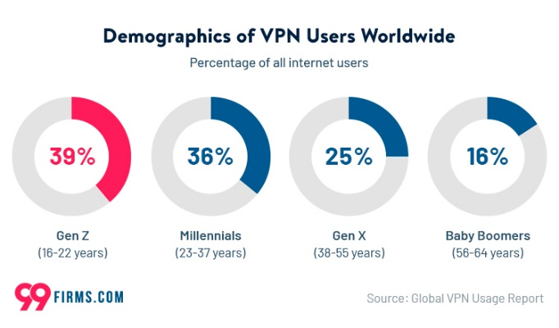

Figure 10: A sample graph of VPN users world wide

## Influential Factors in Choosing VPN Services

The process of selecting VPN services involves a complex web of interconnected factors that mirror the varied preferences and requirements of users. Foremost among these considerations is the pivotal emphasis on privacy and security. Users prioritize robust encryption, stringent no-logs policies, and advanced data protection features in their chosen VPNs. Additionally, the extent and speed of server coverage are crucial elements, with users seeking services boasting expansive server networks for seamless access to geo-restricted content alongside optimal connection speeds.

The ease of use of the VPN interface, compatibility across multiple devices, and accessible customer support also significantly influence decisions, emphasizing the importance of user-friendly experiences. Cost-effectiveness and subscription plans inevitably factor in, as users weigh the offered value against pricing structures. Moreover, the impact of referrals, online feedback, and the reputation of VPN providers holds substantial sway, fostering trust and dependability. Ultimately, this intricate interplay defines the landscape of VPN services, offering diverse options to cater to a wide range of user preferences and needs within VPN Technologies.

Geographical reach and server locations become pivotal factors for those seeking to bypass geo-restrictions or access region-specific content. Users often prefer VPNs with a global server network, allowing them to choose from a diverse range of locations and ensuring optimal performance. Speed and performance metrics also come into play, as users evaluate the impact of VPNs on their internet speed, latency, and overall network performance.

Additionally, the user interface and ease of use significantly influence VPN choosage. Intuitive applications with user-friendly interfaces appeal to a broader audience, catering to both novice and experienced users alike. Pricing models and subscription plans contribute to the decision-making process, with users weighing the cost against the offered features and services.

Ultimately, the nuanced interplay of privacy, security, global accessibility, performance, usability, and cost defines the complex landscape that shapes the selection of a VPN service. As users navigate this multifaceted decision-making process, they seek a balance that aligns with their specific preferences and requirements, emphasizing the need for VPN providers to offer a comprehensive and tailored solution.

## Privacy Concerns and Logging Policies

Privacy concerns and logging policies stand at the forefront of user considerations when selecting a VPN service, and this research scrutinizes the nuanced landscape surrounding VPN Sneak in this context. Users place a paramount emphasis on safeguarding their online privacy, and the analysis delves into the intricacies of VPN Sneak's logging policies. By examining the extent to which VPN Sneak retains user data and the specific information logged, the research aims to provide transparency about how the service aligns with users' expectations regarding privacy protection.

VPN Sneak's commitment to user privacy is manifested in its meticulous logging policies. The research investigates the specifics of VPN Sneak's data handling practices, exploring whether the service adopts a strict no-logs policy or retains minimal, essential data for operational purposes. Moreover, the paper assesses how VPN Sneak communicates these policies to its users, emphasizing the importance of transparent and easily understandable privacy practices. By shedding light on the intricacies of privacy concerns and logging policies, the research contributes to a comprehensive understanding of how VPN Sneak prioritizes user privacy and aligns with evolving user expectations in an era of heightened digital scrutiny.

The transparency of a VPN provider's logging practices becomes pivotal, with users scrutinizing the intricacies of data retention policies. Services that are explicit about the types of information they collect, the purposes for which it is used, and the duration of data retention often gain favor. Users gravitate towards VPNs that champion minimal data collection and emphasize anonymity, aligning with the core tenets of digital privacy.

In an era where data privacy is increasingly valued, users seek VPNs that champion their right to online anonymity. The assurance that personal information is not tracked, recorded, or shared enhances the appeal of a VPN service, fostering a symbiotic relationship between user expectations and provider commitments. Consequently, privacy concerns and logging policies serve as pivotal elements in the discerning process, shaping the landscape for users in their quest for a trustworthy and privacy-centric VPN solution.

# Conclusion

In conclusion, this research paper extensively explored the multifaceted realm of Virtual Private Networks (VPNs), encompassing diverse technologies, applications, and performance evaluation methodologies. Our investigation commenced with a thorough survey of VPN technologies, spanning from mobile apps to innovative Raspberry Pi solutions, assessing both their convenience and security aspects. The examination unveiled the transformative potential of Raspberry Pi as a cost-effective and highly customizable platform, empowering users with greater control over their online security and privacy.

The scrutiny of VPN performance evaluation methodologies provided crucial insights into the essential factors that organizations and individuals should consider when gauging the efficiency and effectiveness of VPN services. Metrics such as throughput, latency, jitter, and packet loss emerged as pivotal considerations, ensuring a seamless and secure online experience.

Moreover, we underscored the paramount importance of data integrity in VPNs, highlighting the significance of encryption strength and secure key management to safeguard sensitive information during transmission. In an era marked by escalating cybersecurity threats and growing reliance on remote connectivity, this research serves as a valuable resource for individuals, businesses, and organizations navigating the intricate terrain of VPN technologies.

As we anticipate the future, the dynamic landscape of VPNs continues to evolve, maintaining its pivotal role in ensuring online security and privacy. This research establishes a foundational framework for ongoing exploration and innovation in the field, offering a roadmap to enhance the performance, reliability, and integrity of VPN services in our increasingly interconnected digital world.

##### Acknowledgment

I extend my sincere appreciation to Ms. Sonali L. Mortale, Head of the Department of Information Technology at Pimpri Chinchwad Polytechnic, for her invaluable guidance and unwavering support throughout the research process. Her expertise and mentorship have played a pivotal role in shaping this study. I am profoundly grateful for her generous allocation of time, patience, and encouragement, which have been crucial contributors to the successful completion of this research paper.

##### References

1. Alice, Bob, Carol, J. Beznazwy, and A. Houmansadr. How China Detects and Blocks Shadowsocks. In ACM Internet Measurement Conference (IMC), 2020.
2. Stealth VPN - Astrill VPN. https://www.astrill.com/ features/vpn-protocols/stealth-vpn.
3. S. Bagui, X. Fang, E. Kalaimannan, S. C. Bagui, and J. Sheehan. Comparison of machine-learning algorithms for classification of vpn network traffic flow using time-related features. In Journal of Cyber Security Technology, 2017.
4. L. Bernaille, R. Teixeira, I. Akodjenou, A. Soule, and K. Salamatian. Traffic classification on the fly. In Computer Communication Review, Association for Computing Machinery, 2006.
5. BolehVPN Traffic Obfuscation Keeps You out of Trouble. [https://www.vpnmentor.com/blog/bolehvpn-trafficobfuscation- keeps-you-out-of-trouble/](https://www.vpnmentor.com/blog/bolehvpn-trafficobfuscation-%20keeps-you-out-of-trouble/).
6. A. Dunna, C. O’Brien, and P. Gill. Analyzing china’s blocking of unpublished tor bridges. In 8th USENIX Workshop on Free and Open Communications on the Internet (FOCI 18).
7. Z. Durumeric, D. Adrian, A. Mirian, M. Bailey, and J. A. Halderman. A search engine backed by Internet-wide scanning. In 22nd ACM Conference on Computer and Communications Security, 2015.
8. R. Ensafi, D. Fifield, P. Winter, N. Feamster, N. Weaver, and V. Paxson. Examining How the Great Firewall Discovers Hidden Circumvention Servers. In Proceedings of the 2015 Internet Measurement Conference.
9. R. Ensafi, P. Winter, A. Mueen, and J. Crandall. Analyzing the great firewall of china over space and time. Proceedings on Privacy Enhancing Technologies, 2015.
10. S. Frolov, J. Wampler, and E. Wustrow. Detecting Probe-resistant Proxies. In Network and Distributed System Security, 2020.